**Login form**

<!DOCTYPE html>

<html>

<head>

<meta name="viewport" content="width=device-width, initial-scale=1">

<title> Login Page </title>

<style>

Body {

font-family: Calibri;

}

button {

background-color: blue;

width: 30%;

color: white;

font-size: medium;

border: none;

cursor: pointer;

}

form {

border: 1px solid purple;

margin: 20px;

}

input[type=text], input[type=password] {

width: 90%;

margin: 10px;

padding: 12px 20px;

display: inline-block;

border: 1px solid black;

box-sizing: border-box;

border-radius: 30px;

}

input[type=text]:focus, input[type=password]:focus {

background-color: lightblue;

}

button:hover {

opacity: 0.7;

}

.container {

padding: 25px;

background-color: lightyellow;

}

</style>

</head>

<body>

<center> <h1>Login Form</h1> </center>

<form>

<div class="container">

<label>Email or Username: </label>

<input type="text" placeholder="Enter Email or Username" name="username" required> <br>

<label>Password : </label> <br>

<input type="password" placeholder="Enter Password" name="password" required>

<button type="submit">Login</button>

<br>

Forgot <a href="#"> password? </a>

</div>

</form>

</body>

</html>

**Output :**

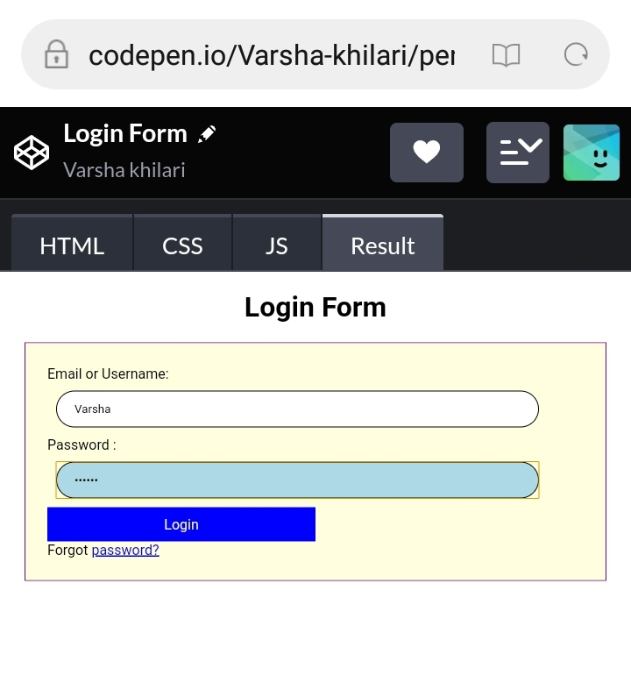

**Registration Form**

<!DOCTYPE html>

<html>

<head>

<meta name="viewport" content="width=device-width, initial-scale=1">

<style>

body{

font-family: fantasy;

background-color: pink;

}

.container {

padding: 40px;

background-color: lightblue;

}

input[type=text], input[type=password] {

width: 90%;

padding: 10px;

margin: 5px 0 15px 0;

display: inline-block;

border: bottom 1px;

background: #f1f1f1;

font-family: Calibari;

}

input[type=text]:focus, input[type=password]:focus {

background-color: lightyellow;

outline: none;

}

div {

padding: 10px;

}

hr {

border: 0.5px solid red;

margin-bottom: 25px;

}

.registerbtn {

background-color: blue;

color: white;

padding: 16px 20px;

margin: 8px 0;

border: none;

cursor: pointer;

width: 35%;

opacity: 0.9;

}

.registerbtn:hover {

opacity: 1;

}

.resetbtn {

background-color: blue;

color: white;

padding: 16px 20px;

margin: 8px 0;

border: none;

cursor: pointer;

width: 30%;

opacity: 0.9;

}

</style>

</head>

<body>

<form>

<div class="container">

<center> <h1>Registration Form</h1> </center>

<hr>

<label> First-Name: </label>

<input type="text" name="firstname" placeholder= "Firstname" size="15" required />

<label> Middle-Name: </label>

<input type="text" name="middlename" placeholder="Middlename" size="15" required/>

<label> Last-Name: </label>

<input type="text" name="lastname" placeholder="Lastname" size="15"required/>

<label>Email: </label>

<input type="text" placeholder="Enter Email" name="Email" required> <br>

<div>

<label>

<label>

Gender :

</label><br>

<input type="radio" value="Male" name="gender" checked > Male

<input type="radio" value="Female" name="gender"> Female

</div>

<label for="psw"><b>Password</b></label>

<input type="password" placeholder="Enter Password" name="psw" required>

<label for="confirm-psw"><b>Confirm Password</b></label>

<input type="password" placeholder="Confirm Password" name="confirm-psw" required>

<button type="submit" class="registerbtn">Register</button>

<button type="submit" class="resetbtn">Reset</button>

</form>

</body>

</html>

**Output :**

